

**Trunk or Treat**

**HALLOWEEN PARTY**

**Thursday, October 23**

**6:30-7:30pm**

**Rebecca S. Breed Clubhouse @ 4 Horseneck Lane**

**\*There will be no evening programs\***

The Club will **CLOSE** at 5:30pm so members can go home to get dressed for the SPOOKY & FUN event.

The front pick-up loop & parking garage will be CLOSED at 4:00pm on this day. ALL parents/guardians must park across the street and walk to the Club to pick up their child(ren).

**Members must be dressed in costume and will go trick or treating with their parents**

Apples, apple cider & music

Halloween Bags donated by the Greenwich Police Silver Shield Association

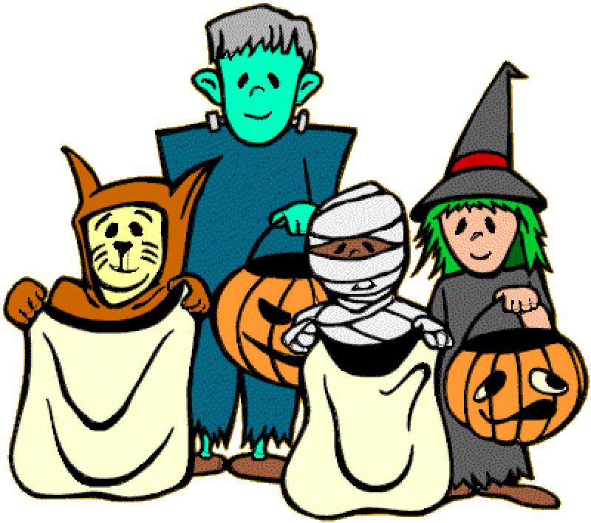Safe – Friends – Your Club & Scary FUN!

For more information, contact the Boys & Girls Club

at (203) 869-3224